UA-SER Report

Data Insights
4 classes: angry/happy/sad/neutral
balanced emotion distribution (222–259 per class)
gender imbalance: female 593 vs male 359; sad heavily female-skewed (187F vs 40M)
mean duration 2.07s, range 0.52–5.50s
speaker-disjoint split: 651 train / 120 val / 181 test

Feature Engineering
86-dim vector: 40 MFCC mean + 40 MFCC std + F0 mean/std + RMS mean/std + ZCR mean/std
SSL: wav2vec2-xls-r-300m fine-tuned end-to-end with frozen backbone (last 6 transformer blocks unfrozen)
SSL: emotion2vec+ used as frozen feature extractor - 768-dim utterance embeddings - MLP classifier
Augmentation tested: Gaussian noise, time stretch, pitch shift (via audiomentations)

Tried Algorithms and Models
Logistic Regression, SVM (RBF), Random Forest
MLP 2-layer
wav2vec2-xls-r-300m fine-tuned for classification (language transfer)
emotion2vec_plus_base as feature extractor + MLP head (task transfer)
Loss Ablation: CE vs Focal Loss (γ=2), with/without augmentation
Freeze Ablation: 0, 3, 6, 12 layers unfreezed

Chosen Hyperparameters
SSL fine-tuning: AdamW, lr=1e-4, weight_decay=1e-2, grad clip=1.0, batch=8
Focal Loss: γ=2.0
MLP head on emotion2vec: AdamW lr=1e-3, dropout=0.3, batch=32
Frozen: all backbone except last 6 transformer blocks + classifier head

Metrics

Model | Val UAR | Test UAR
Logistic Regression (MFCC) | 0.422 | —
SVM (RBF) (MFCC) | 0.459 | —
Random Forest (MFCC) | 0.395 | —
MLP (MFCC) | 0.493 | —
wav2vec2 CE single (10 ep) | 0.580 | 0.661
emotion2vec+ (frozen, MLP head) | 0.554 | 0.589
wav2vec2-xls-r CE (no aug) | 0.577 | 0.598
wav2vec2-xls-r FL (no aug) | 0.466 | 0.544
wav2vec2-xls-r CE (aug) | 0.450 | 0.477
wav2vec2-xls-r FL (aug) | 0.607 | 0.600

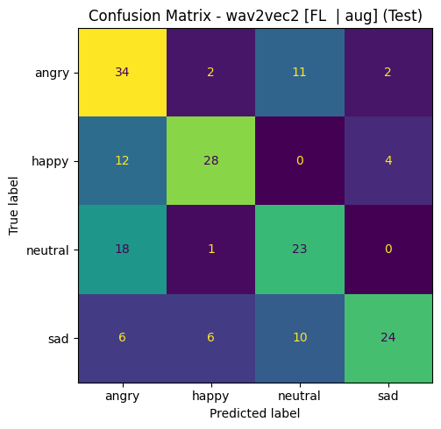

Insights and Conclusions
Handcrafted features alone are insufficient ~0.46–0.49 UAR
Happy/angry + neutral/sad confusion
Language transfer (wav2vec2) > task transfer (emotion2vec+): wav2vec2-xls-r (CE, frozen-6) 0.661 UAR, emotion2vec+ 0.589 UAR.
Aug improves FL, reduces CE
wav2vec2-xls-r (CE, frozen-6, 10 epochs). Best UAR 0.661 catches Havrylyuk results (0.65–0.70).
Unfreezing more improves, less unfreezing - worse results

